**CS112 PROJECT**

**PROBLEM STATEMENT:**

In this project, a number of quizzes are available on a topic. The user will pick a quiz and select the best choice. At the end, the score achieved will be displayed.

**INTRODUCTION:**We built a system with a couple of quizzes and a user can choose any one of them and at the end of the quiz, the name, registration number and the score of the user is stored in the excel file.

**FUNCTIONAL REQUIREMENTS:**We’re taking user’s name and registration number through vectors which is unique so we can differentiate between users of the same name. Moreover we’re providing security to the user’s information. We are providing readability and reusability along with performance. We’re comparing the user’s answers with the actual answers and saving the score of the user. We have used pure virtual functions along with polymorphism and Inheritance. We have also overloaded the << operator. We have used exception handling to improve the code.

**C++ CODE:**

Using inheritance and file handling

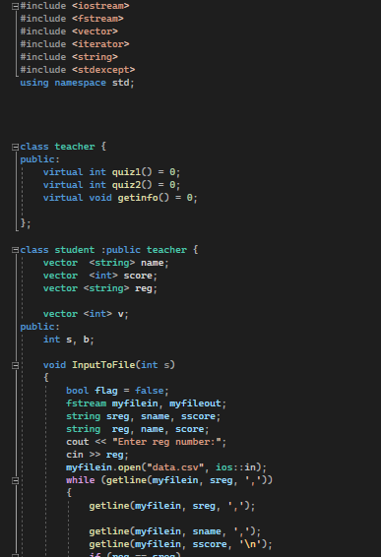

Use of vectors

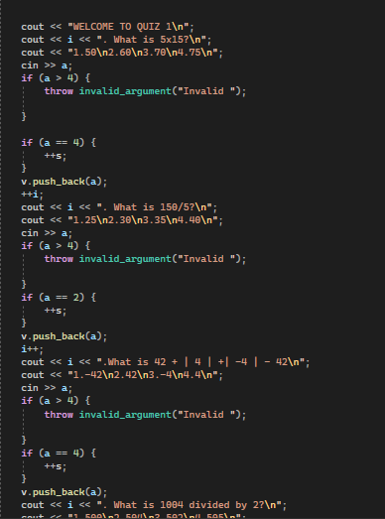

Use of exception handling and operator overloading

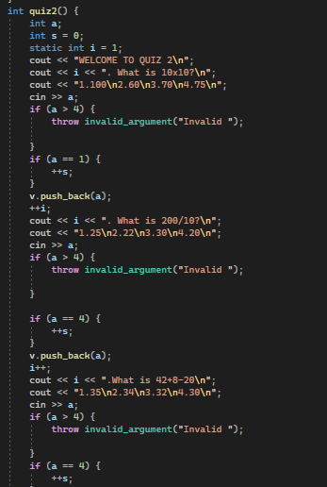

Use of polymorphism

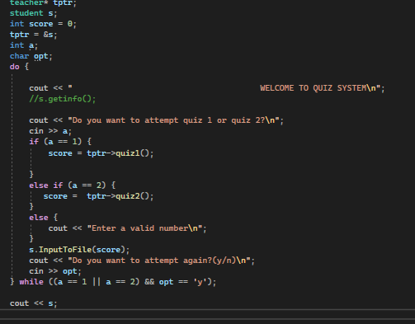

UML class diagram:

“ABSTRACT CLASS”

TEACHER

InputToFile()

Int quiz1()

Int quiz2()

Getinfo

vector <string> name

vector <int> score

vector <string> reg

int s

Student class

virtual int quiz1() =0;

virtual int quiz2() =0;

Derived class

Base class